|  |  |
| --- | --- |
|  |  |
|  |  |
|  |  |
|  |  |
|  |  |
|  |  |
|  |  |
|  |  |
|  |  |
|  |  |
|  |  |
|  |  |
|  |  |
|  |  |

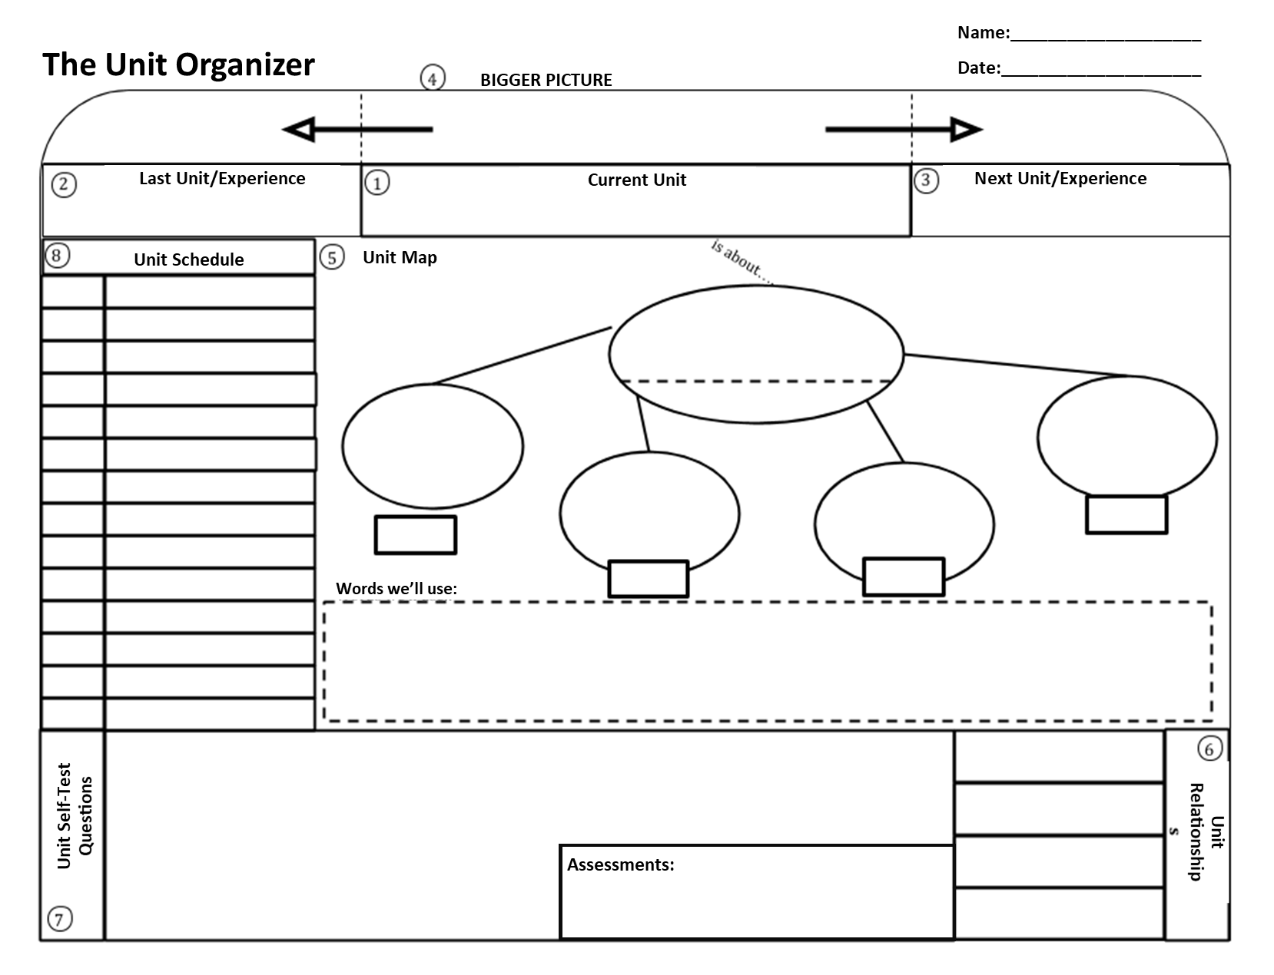

Type here

Linking words here

Linking words here

Linking words here

Linking words here

Type here

Type here

Type here

Type here

Type here

Type here

1. Type Here
2. Why
3. What

Type here

Type here

Type here

Type here

Type here

Type here

Type here